## Task 1.1

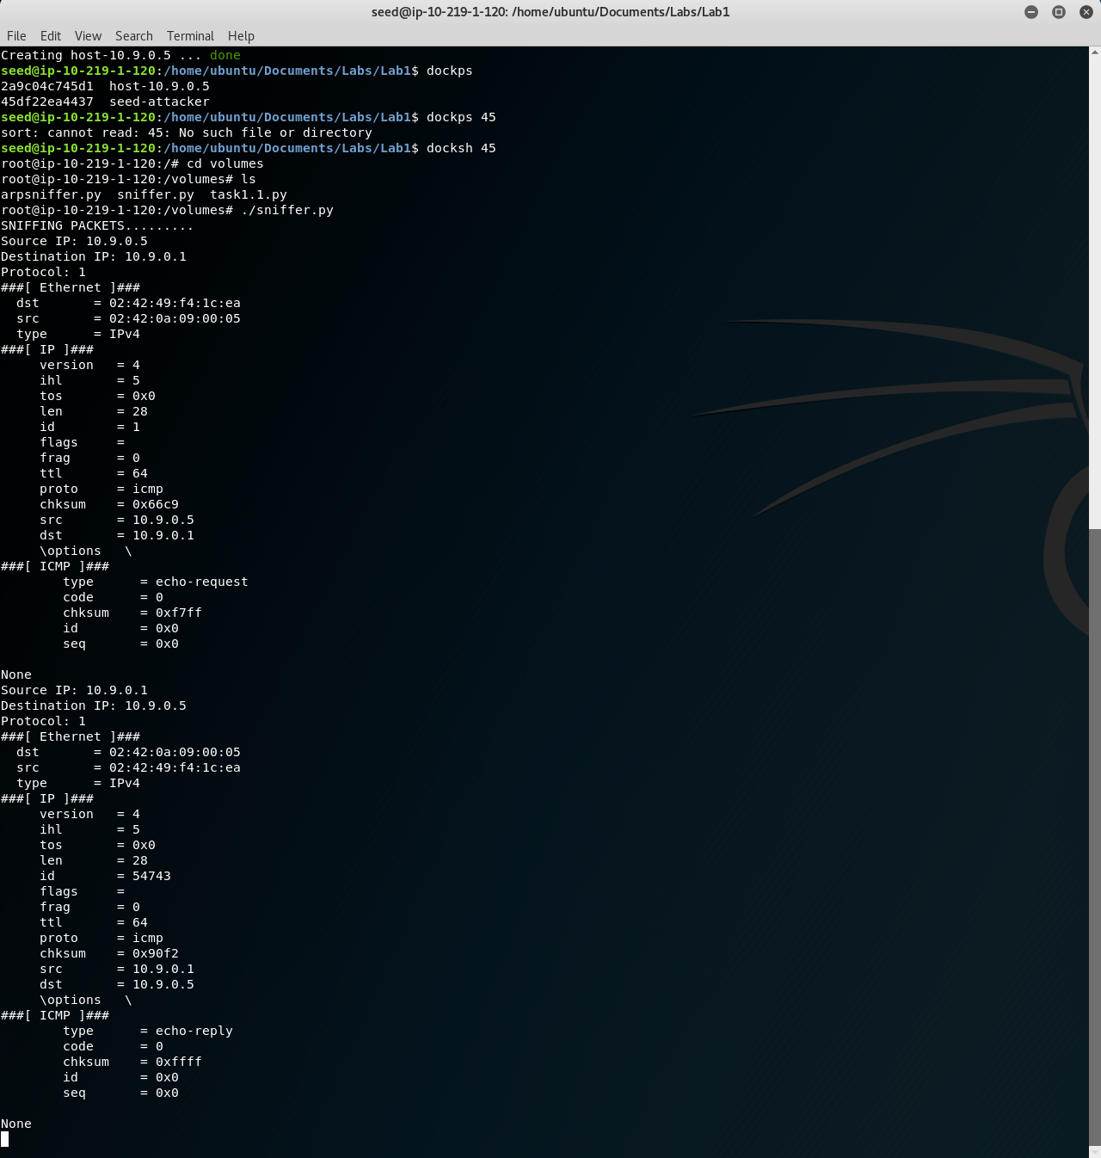

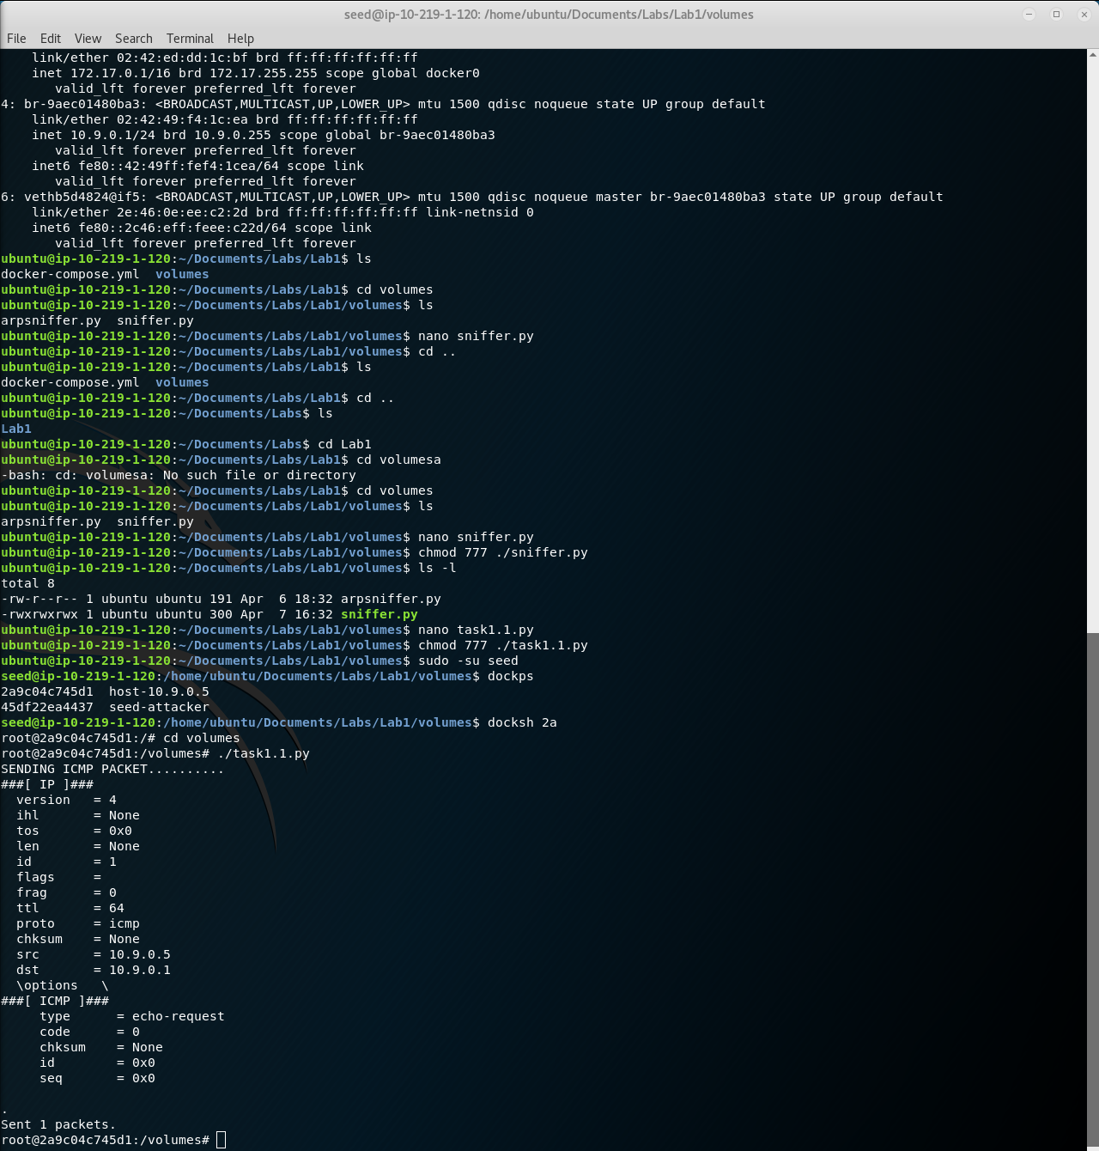

The host container is sending a simple echo request that the sniffer script is receiving. The sniffer script displays the checksum of said request (labeled as none from the sender of the initial request). The sniffer script then sends a reply to the original sender, which has a different checksum along with it.

## Task 1.2

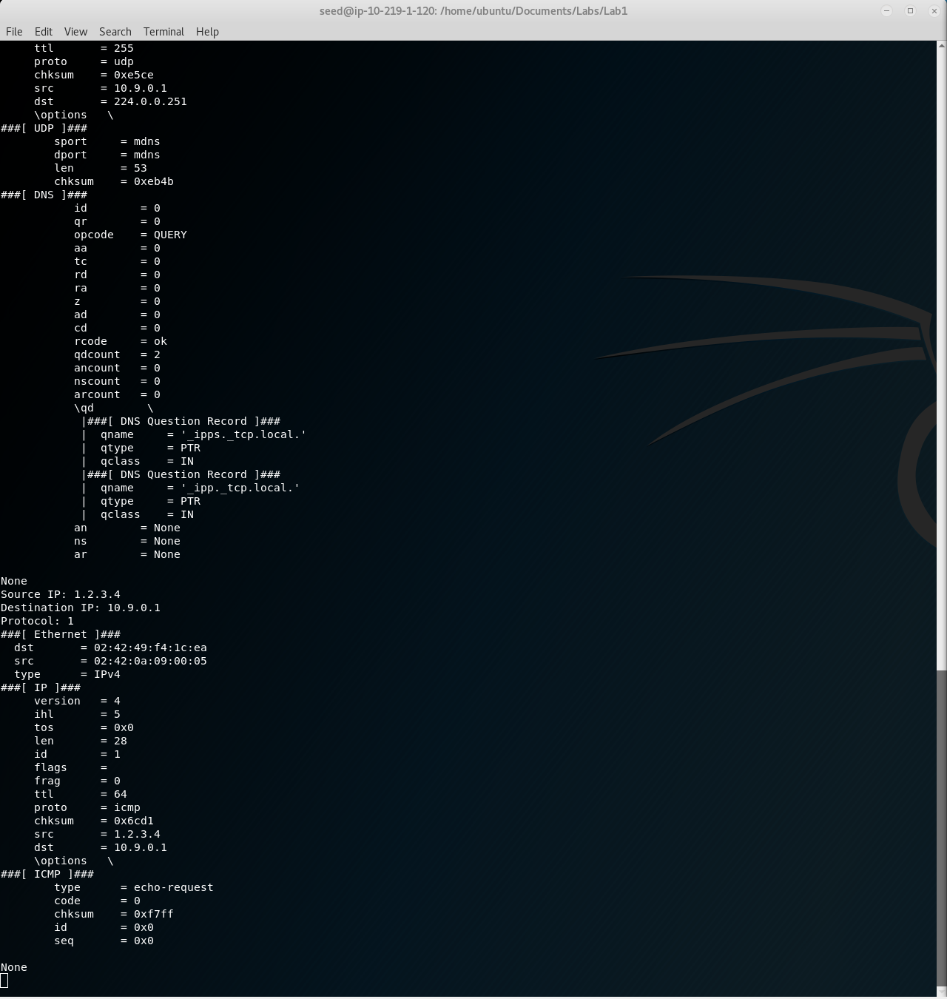

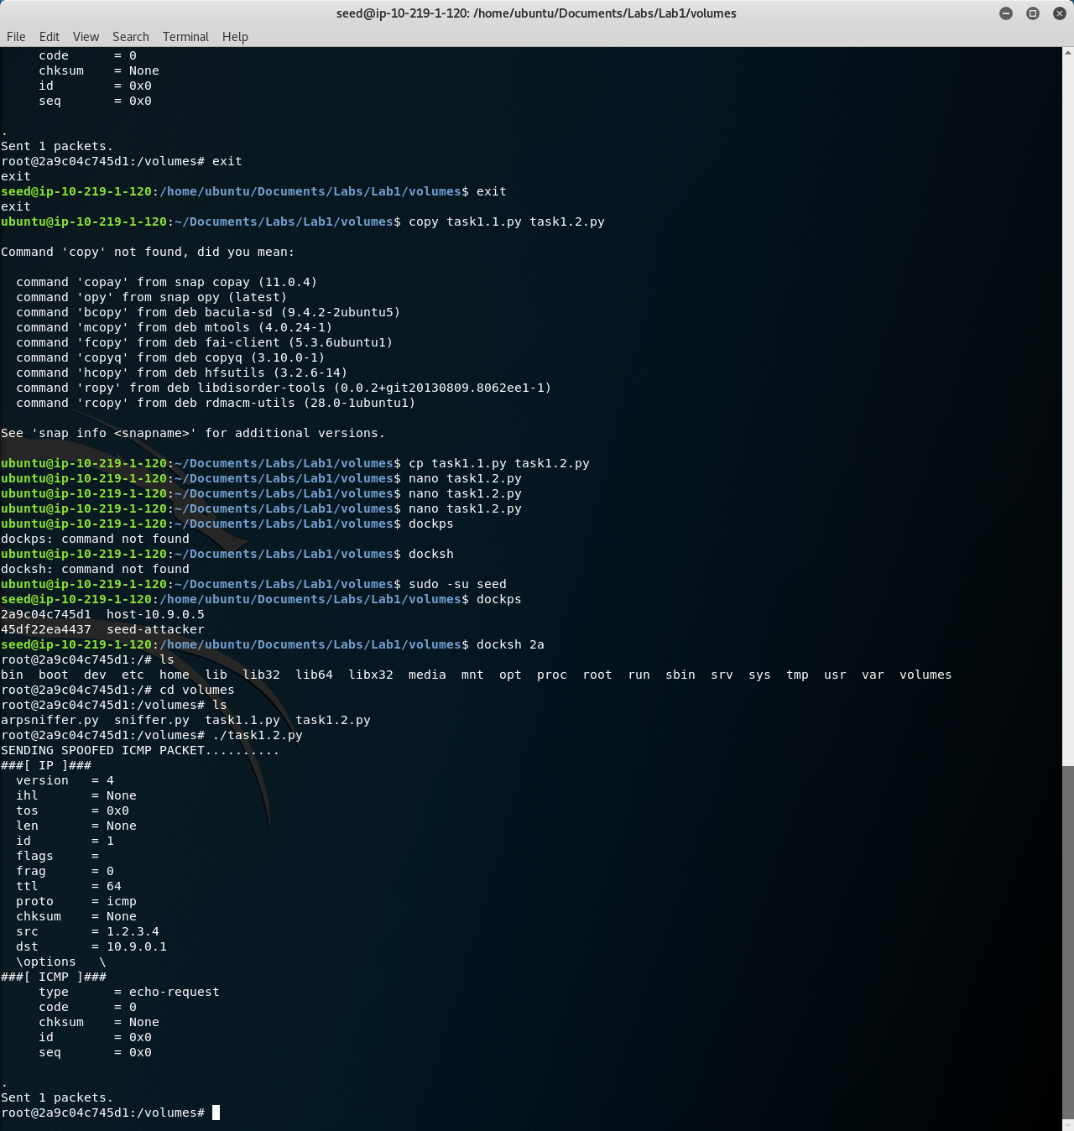

The output here is the same as the output in the previous section, but the big difference is the value of the “src” variable. The source IP address is something completely different than before, and is especially notable since both scripts are being run from two containers on the same system, meaning the first parts of the IP addresses should theoretically be the same, but the attacking script causes otherwise.

## Task 2.1

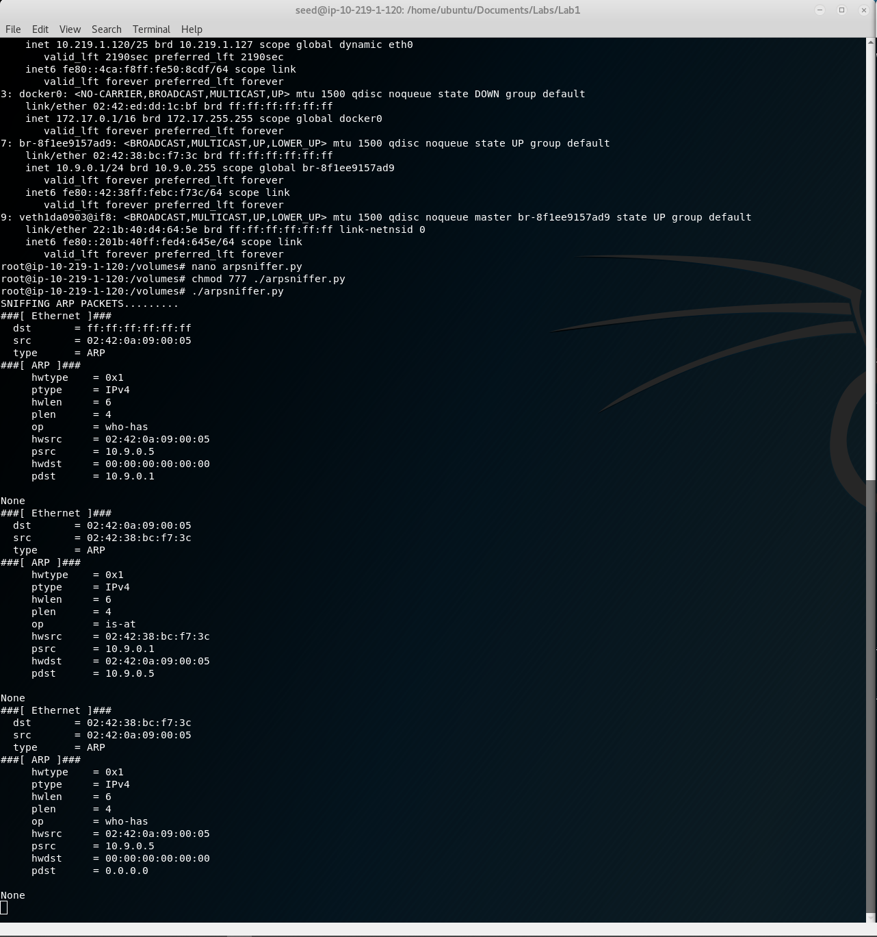

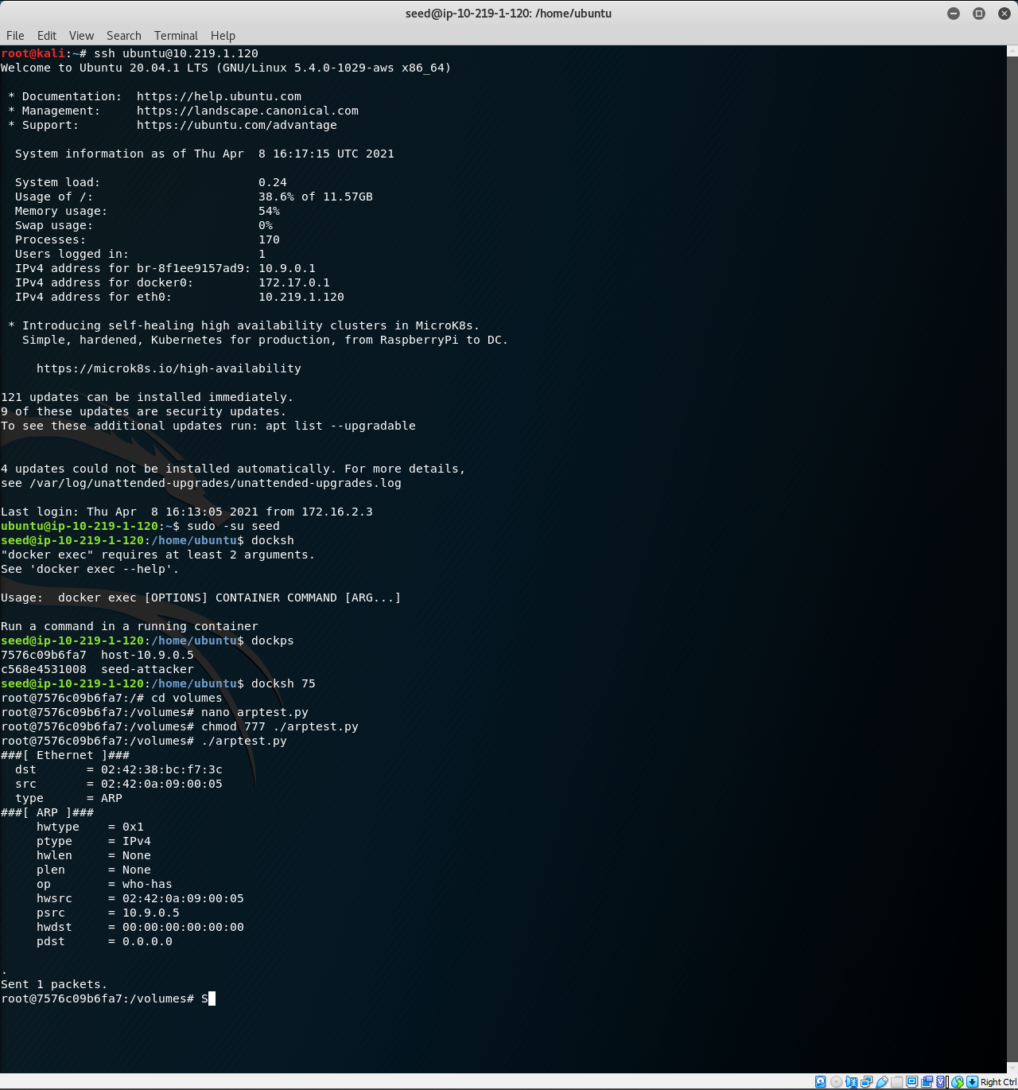

The output is a back and forth request and reply from the ARP protocol. The notable thing is that pdst attribute is not specified in the sent packet on the host side (bottom, 0.0.0.0, meaning the request is being broadcast to the entire network to essentially ask who has the MAC address it’s looking for. The third listing on the seed-attacker side is an attempt to update the ARP cache by sending an ARP request back, the same way the host did originally.

## Task 2.2

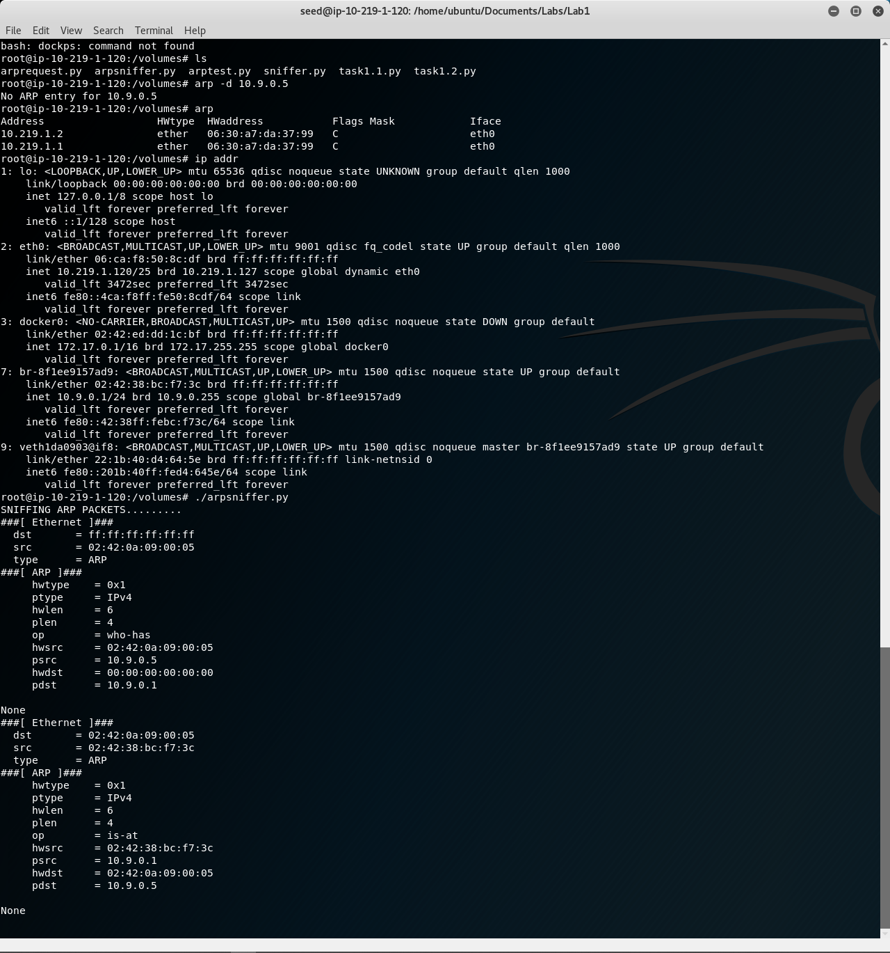

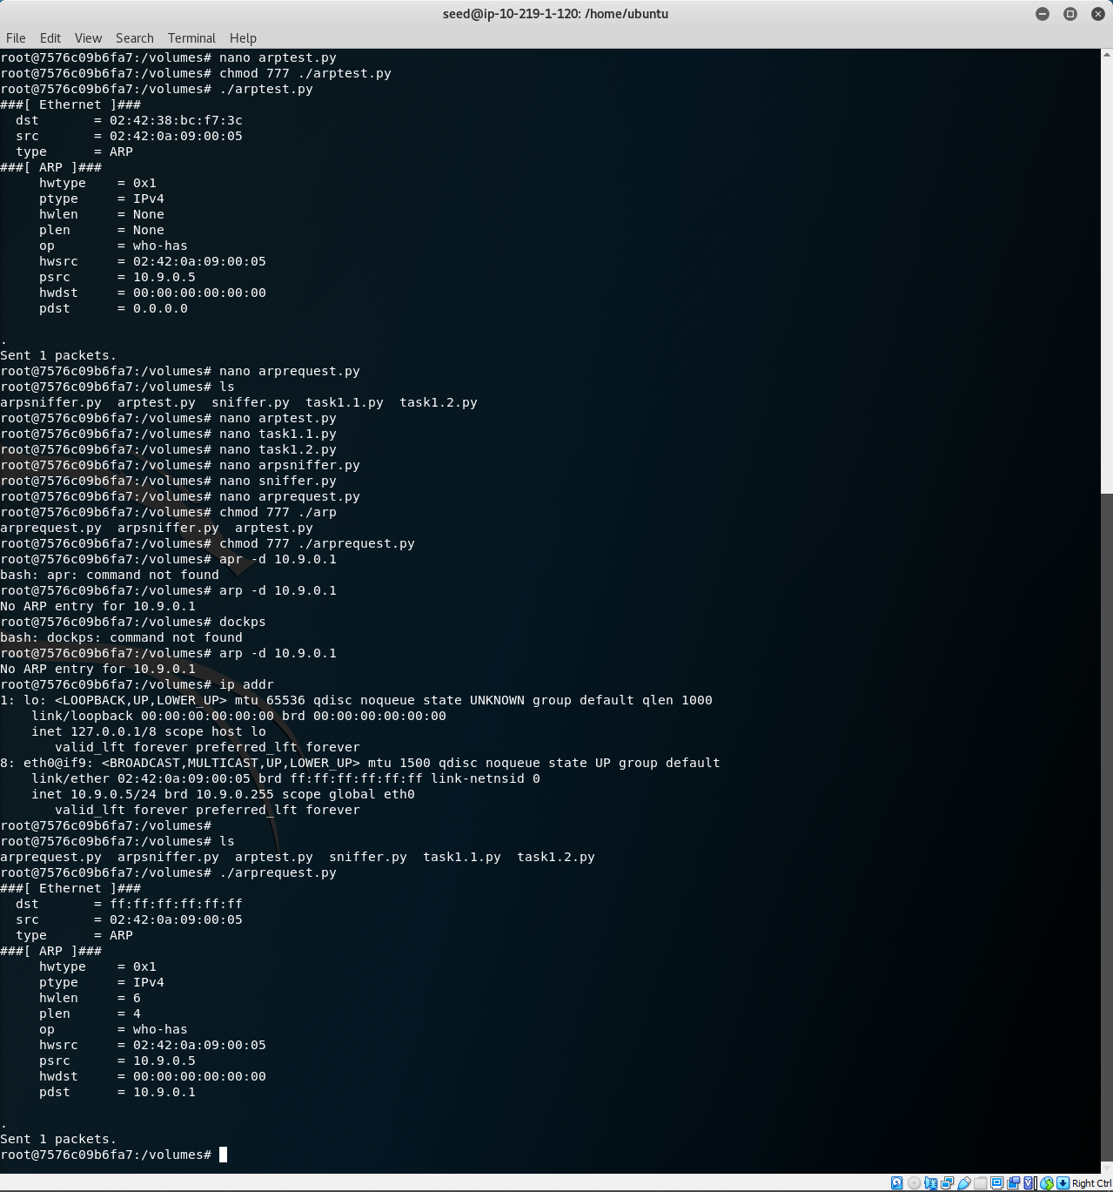

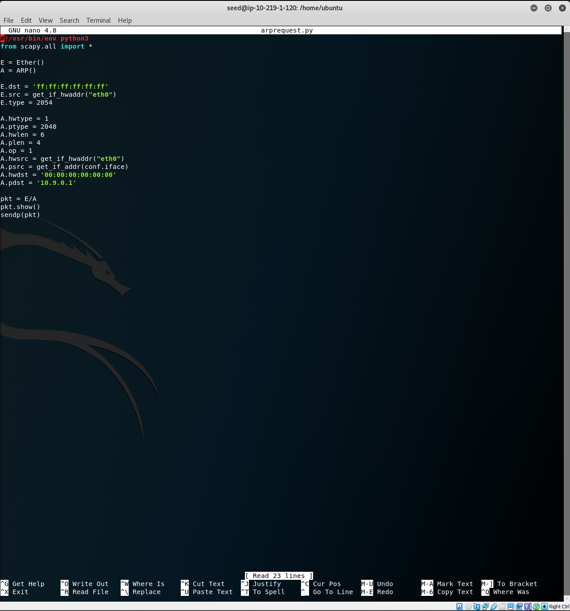

## Task 2.3

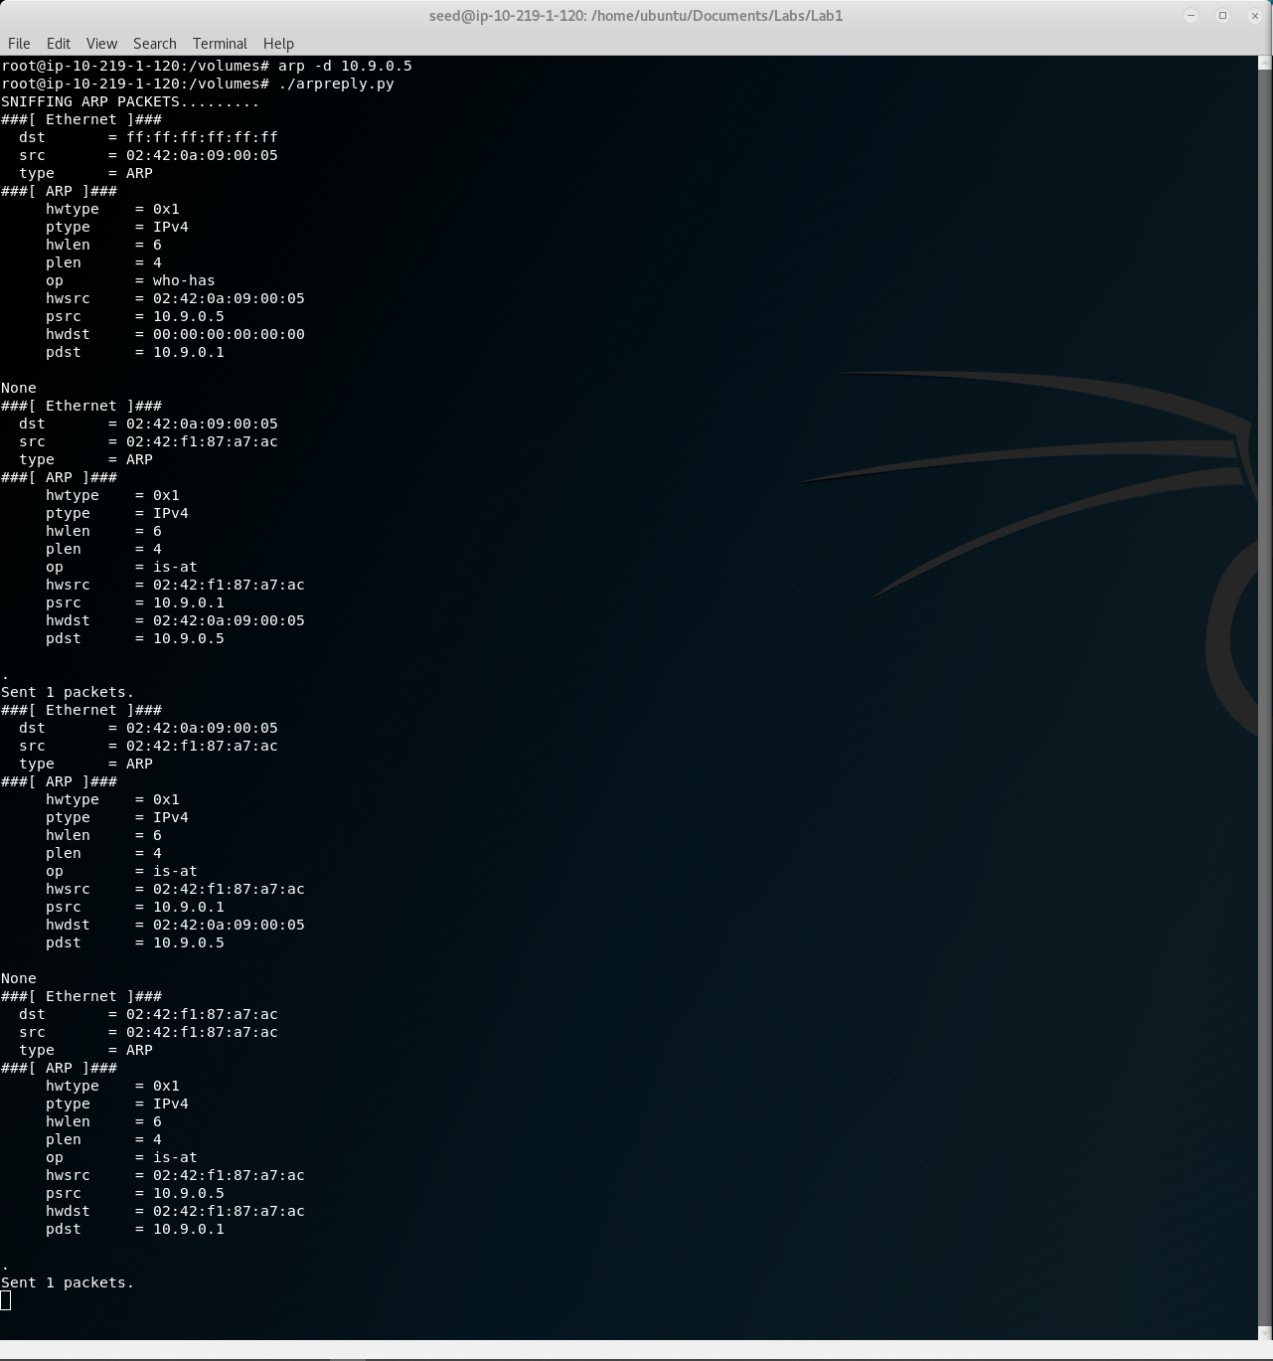

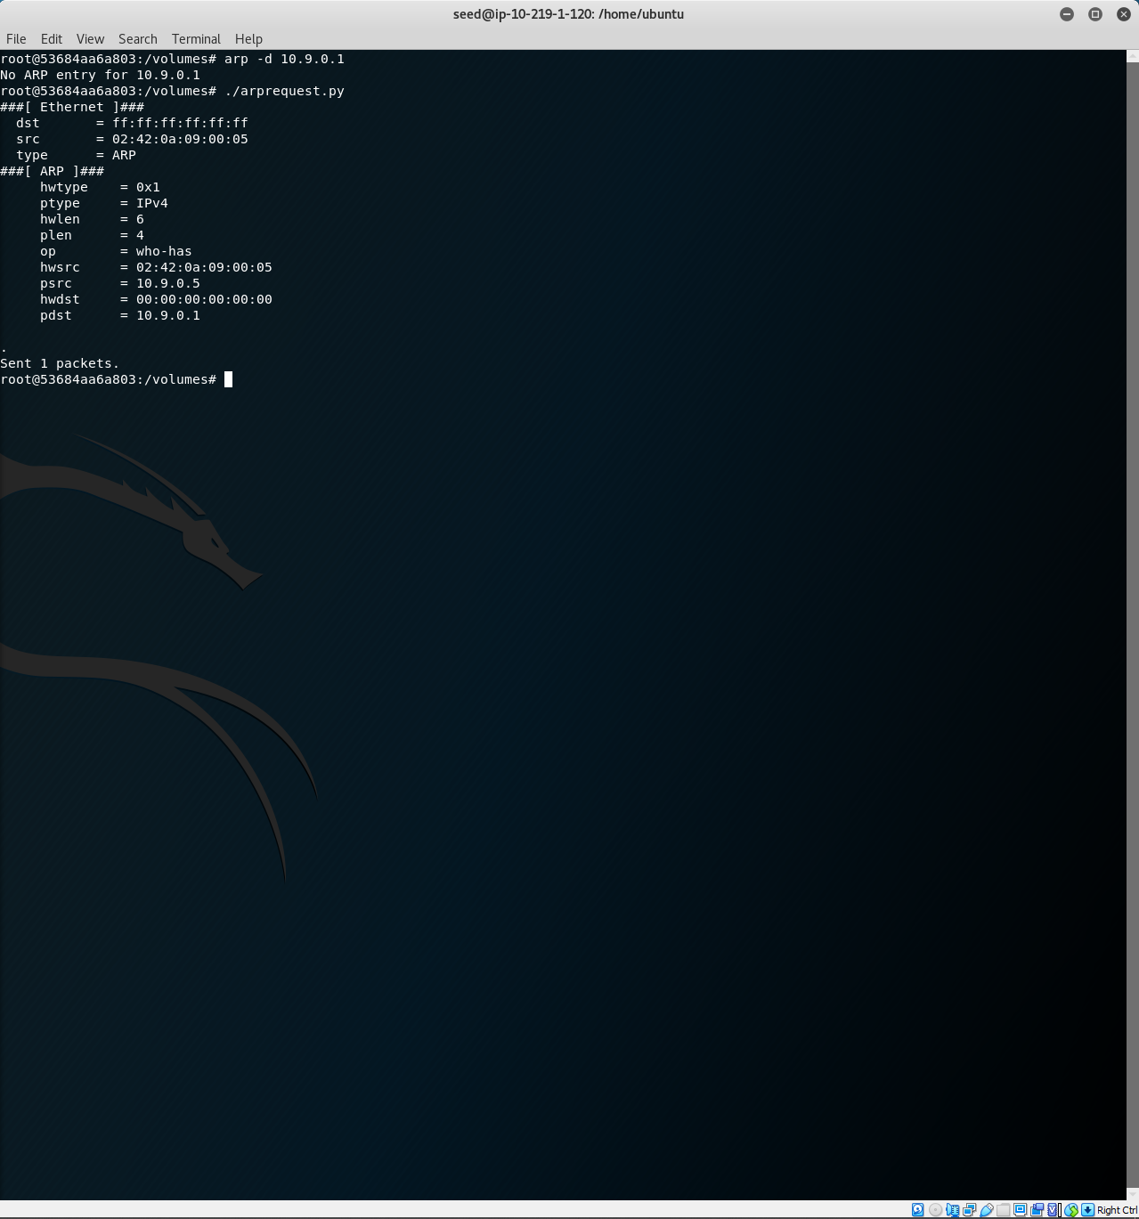

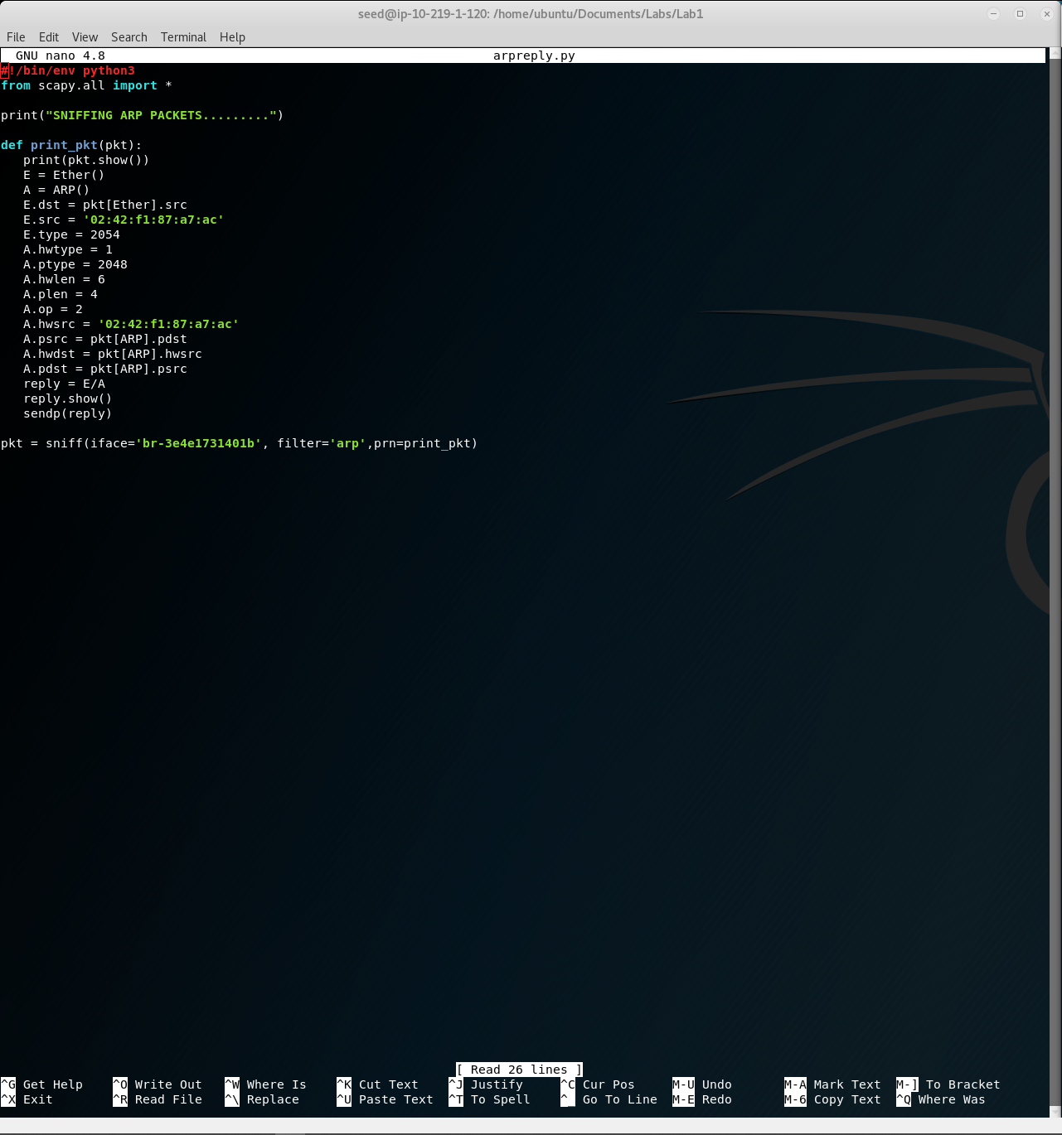

I’m aware the output for the arpreply.py script doesn’t look correct, the instructions for that one in particular felt very vague, some instructions were conflicting (don’t hard code values but also don’t use default values/explicitly specify values). I made sure the only address-related value I hard coded was the MAC address for the attacker, everything else came from the incoming packet (making it dynamic), I specified op = 2 for a reply packet. The last print is a bunch of duplicates which I know isn’t correct, but I did the best I could given the instructions.